Java Collections Framework
Complete Study Notes — In Simple Language
Combined from two source PDFs, reorganized, simplified, with code examples and a full answered interview question bank.

1. Why Do We Need Collections?
Think of a variable like a small box that can hold exactly one value. If you need to store 1000 values, you would need 1000 boxes (variables) — that's not practical.
Arrays solve this by letting you store many values under one name. But arrays have two big problems:
- Fixed size — once you create an array of size 5, it can never grow or shrink. You must know the size in advance.
- Same data type only — a normal array can hold only one type of data. You can use an Object[] array to get around this, but then you lose ready-made features like sorting and searching.
Collections were built to fix both problems: they grow/shrink automatically, they can hold a mix of object types, and every collection class is built on a proper data structure, so Java already gives you ready-made methods for inserting, deleting, searching and sorting.

2. "Collection" vs "Collections" — Don't Mix Them Up
Term | What it is | Purpose
Collection | An interface | Represents a group of objects as a single unit. It is the root of the whole framework.
Collections | A utility class (java.util.Collections) | Provides ready-made static helper methods (sorting, searching, synchronizing) that work on collection objects.

3. The Collections Family Tree (In Plain Words)
Everything branches out from one root interface called Collection:
Branch 1 — List (keeps order, allows duplicates)
- ArrayList, LinkedList, Vector, Stack all implement List.
Branch 2 — Set (no duplicates allowed)
- HashSet, LinkedHashSet, TreeSet implement Set.
- SortedSet is a child of Set, NavigableSet is a child of SortedSet, and TreeSet implements NavigableSet.
Branch 3 — Queue (processes items in a particular order)
- PriorityQueue, LinkedList, BlockingQueue implement Queue.
Map — a separate family (key-value pairs)
- Map is NOT a child of Collection — it lives on its own.
- HashMap, LinkedHashMap, TreeMap, Hashtable, IdentityHashMap, WeakHashMap all implement Map.
- SortedMap is a child of Map, NavigableMap is a child of SortedMap, and TreeMap implements NavigableMap.
- Hashtable has an old child class called Properties, used for reading configuration files.
Arrays and Collections (utility classes)
- Both are utility classes that extend Object directly — just static helper methods, not part of the List/Set/Map family.

3.1 Visual Diagrams
The same family tree described above, drawn out as diagrams. Solid arrows mean "extends" (interface-to-interface, or class-to-class); dashed arrows mean "implements" (a class implementing an interface).
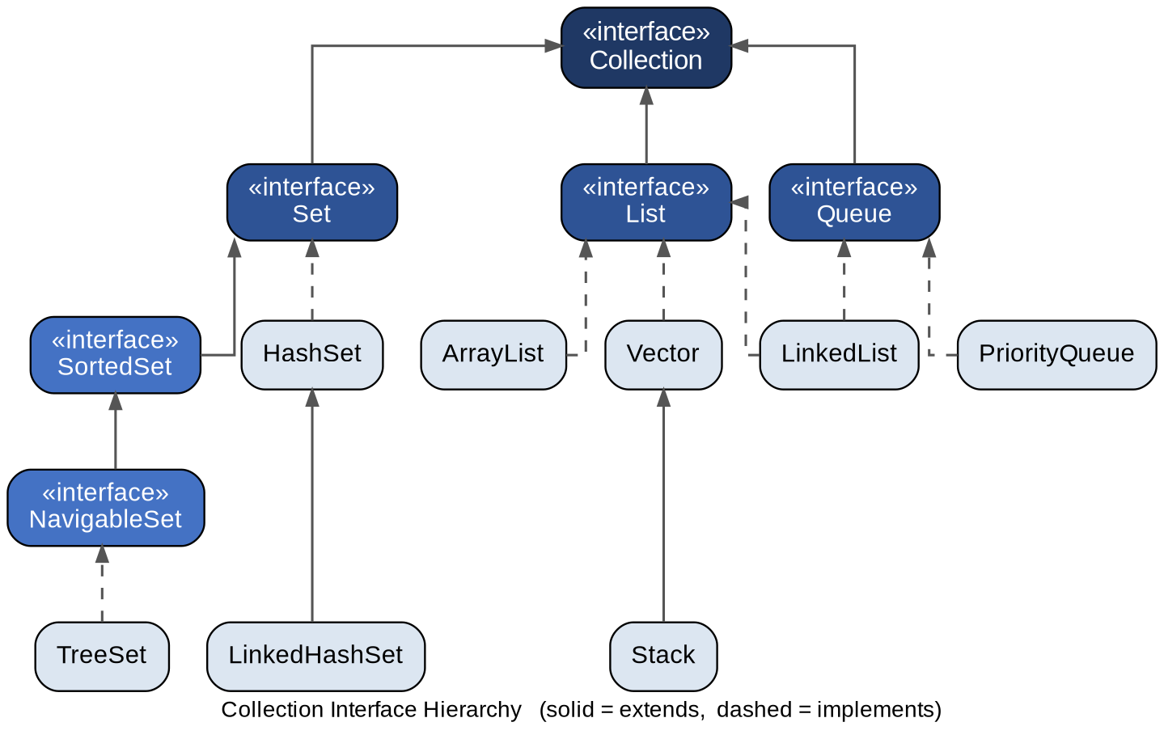
Figure 1 — Collection interface hierarchy (List, Set, Queue branches)
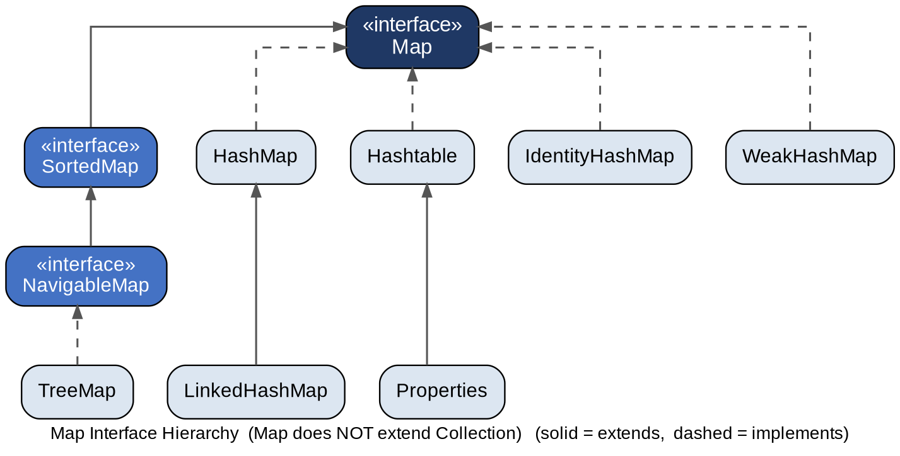
Figure 2 — Map interface hierarchy (a separate family from Collection)
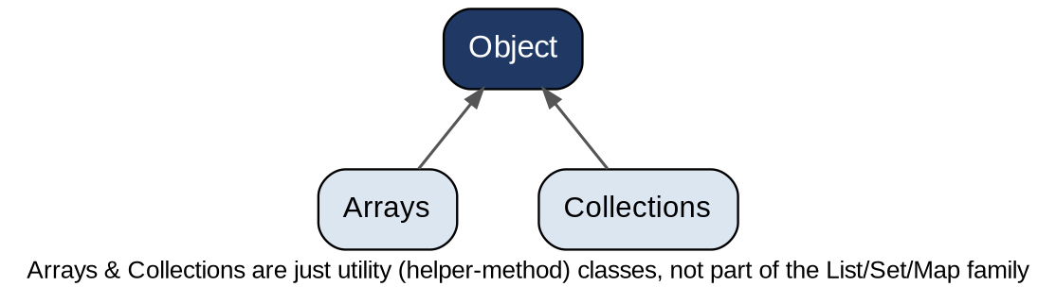
Figure 3 — Arrays and Collections are plain utility classes, not part of either tree above

4. Arrays vs Collections — Side by Side
# | Arrays | Collections
1 | Fixed size — cannot grow or shrink | Growable — resizes automatically
2 | Not memory-efficient | Memory usage is better managed
3 | Slightly faster for simple, fixed-size use | Extra overhead, but much more flexible
4 | Only same-type (homogeneous) elements | Can mix different object types (heterogeneous)
5 | No built-in data structure, so no ready-made methods | Built on real data structures, so tons of ready-made methods
6 | Can hold primitives and objects | Can hold only objects (primitives get auto-boxed)

5. The List Family — Ordered, Duplicates Allowed
A List keeps items in the order you inserted them and lets you have duplicate values. Because order matters, every position has an index number, so List has extra methods like get(index), set(index, value), and add(index, value).

5.1 ArrayList
Internally, ArrayList uses a resizable array. When it fills up, Java quietly builds a bigger array, copies everything over, and keeps going.
- Allows duplicate values, keeps insertion order, can hold different object types, allows null.
- Default starting capacity is 10. Growth formula: new size = (old size × 1.5) + 1.
ArrayList<String> list = new ArrayList<>();
list.add("ashokit");
list.add("hyd");
System.out.println(list); // [ashokit, hyd]

5.2 LinkedList
Internally, LinkedList is a chain of nodes (a doubly linked list) — each item points to the next and previous item.
- Great for frequent insert/delete in the middle — it just re-links the chain, no shifting needed.
- Not great for frequent reads — it has to walk the chain to reach a position.
- Allows duplicates, keeps insertion order, allows null, allows mixed types.
- Extra methods: addFirst(), addLast(), getFirst(), getLast(), removeFirst(), removeLast().

5.3 Vector
Works almost exactly like ArrayList, except every method in Vector is synchronized (thread-safe, but slower). It's a legacy class from Java's first version.

5.4 Stack
A child class of Vector. Follows LIFO — Last In, First Out — like a stack of plates.
- push(item) — add to the top
- pop() — remove and return the top item
- peek() — look at the top item without removing it

5.5 ArrayList vs LinkedList — Quick Comparison
Point | ArrayList | LinkedList
Underlying structure | Resizable array | Doubly linked list (chain of nodes)
Reading/accessing an item | Fast — jumps straight to the index | Slow — must walk the chain step by step
Inserting/deleting in the middle | Slow — has to shift other items | Fast — just re-links neighboring nodes
Best used for | Lots of reading/searching | Lots of inserting/deleting
Implements RandomAccess? | Yes | No

Rule of thumb: mostly reading/searching → ArrayList. Mostly inserting/deleting in the middle → LinkedList.

6. The Set Family — No Duplicates Allowed
A Set only cares about unique values and doesn't need index-based access. Adding a duplicate is silently ignored.

6.1 HashSet
Internally built on a hash table (the same technique behind HashMap). In fact, HashSet is literally implemented on top of a HashMap internally — every element you add becomes a key in a hidden backing HashMap, paired with a constant dummy value. That's why it decides where to store each item using the item's hash code.
- No duplicates.
- Does NOT guarantee insertion order.
- Allows exactly one null value.
- Not thread-safe.

6.2 LinkedHashSet
Same as HashSet, but also keeps a doubly linked list running through the entries, purely to preserve insertion order.

6.3 TreeSet
Internally built on a balanced tree. Automatically keeps all elements sorted (ascending by default).
- No duplicates. Elements always stored in sorted order.
- Allows null only as the very first element of an empty TreeSet — after that, null throws an error because TreeSet must compare values to sort them.
- All elements must be of comparable/same type, or you get a ClassCastException.

6.4 HashSet vs LinkedHashSet vs TreeSet
Property | HashSet | LinkedHashSet | TreeSet
Underlying structure | Hash table (via HashMap) | Hash table + linked list | Balanced tree
Insertion order kept? | No | Yes | No (sorted order instead)
Sorted? | No | No | Yes, always
Duplicates allowed? | No | No | No
Null allowed? | One null | One null | One null only if set is empty

7. The Map Family — Key-Value Pairs
A Map stores data as pairs: a key and a value, like a dictionary. Keys must be unique, but values can repeat.
Important: Map does NOT extend Collection. It has its own methods like put(), get(), keySet(), values(), and entrySet().

7.1 HashMap
The most commonly used Map. Internally built using the hash table technique — it uses each key's hash code to decide where to store the pair, making get/put very fast on average.
- Keys cannot repeat; values can.
- Allows exactly one null key, and multiple null values.
- Does NOT guarantee any particular order.
- Not thread-safe.
Terminology check — "hash table" (two lowercase words) is a general technique: an array of buckets located using a hash code. It is NOT the same thing as the Java class named Hashtable (one word, capital H). HashMap and Hashtable are two separate, independently-coded classes that both happen to use the hash table technique internally. That's why saying "HashMap follows hash table structure" does NOT mean HashMap is built on top of the Hashtable class — they don't call each other's code at all. See the direct comparison and Q25 below for exactly why one is thread-safe and the other isn't, despite sharing the same underlying technique.

7.2 LinkedHashMap
Same as HashMap, but also keeps a doubly linked list to preserve insertion order.

7.3 TreeMap
Internally built on a tree, so it always keeps the keys sorted (ascending by default). Sorting is based only on keys, never on values.

7.4 Hashtable
One of Java's oldest classes (from version 1.0). It also uses the hash table technique internally — but as a completely separate implementation from HashMap — and Sun/Oracle made every one of its methods synchronized, which is what makes it thread-safe. It also refuses null for both keys and values, unlike HashMap.

7.5 HashMap vs Hashtable
Point | HashMap | Hashtable
Underlying technique | Hash table (own implementation) | Hash table (own, separate implementation)
Thread-safe? | No — methods are not synchronized | Yes — every method is synchronized
Speed | Faster | Slower, due to synchronization overhead
Null keys/values | One null key, many null values | No nulls allowed at all
Introduced in | Java 1.2 (modern) | Java 1.0 (legacy)

So why isn't HashMap thread-safe if it "uses a hash table"? Because "using the hash table technique" only describes HOW data is organized internally (buckets + hash codes) — it says nothing about thread-safety. Thread-safety comes from whether the class's methods are wrapped with the synchronized keyword. Hashtable's author added synchronized to every method; HashMap's author deliberately did not, to make it faster for single-threaded use. Both chose the same storage technique but made different design decisions on locking.

7.6 Other, Less Common Maps
- IdentityHashMap — behaves like HashMap, but decides duplicate keys using == (same object in memory?) instead of .equals() (do they look equal?).
- WeakHashMap — behaves like HashMap, but its keys can still be garbage-collected even while stored in the map, if nothing else references them.
- Properties — a child class of Hashtable, used to load settings from .properties files. Both keys and values must be Strings.

8. Ways to Walk Through a Collection (Cursors)
A "cursor" is a tool that lets you go through a collection's elements one at a time. Java gives you three options:
Feature | Enumeration | Iterator | ListIterator
Works on | Legacy classes only (Vector, Stack, Hashtable) | Any collection (List, Set) | Only List-type collections
Direction | Forward only | Forward only | Forward AND backward
Can remove items? | No | Yes | Yes
Can add/replace items? | No | No | Yes (add and set)
Method to create it | elements() | iterator() | listIterator()

8.1 Code Example — Iterator on a List
You can remove elements safely mid-loop using the iterator's own remove() — removing directly from the list itself would throw a ConcurrentModificationException (see section 11.2).
List<String> list = new ArrayList<>(Arrays.asList("Java", "Python", "C++"));
Iterator<String> it = list.iterator();
while (it.hasNext()) {
String val = it.next();
if (val.equals("Python")) {
it.remove(); // safe removal, using the iterator
}
}
System.out.println(list); // [Java, C++]

8.2 Code Example — Iterator on a Set
Set<Integer> set = new HashSet<>(Arrays.asList(10, 20, 30));
Iterator<Integer> it = set.iterator();
while (it.hasNext()) {
System.out.println(it.next());
}
// Order is not guaranteed, since HashSet does not preserve insertion order

8.3 Code Example — Iterating a Map (three ways)
A Map cannot be iterated directly with iterator() because Map does not extend Collection. Instead, you iterate over one of its three "views": entrySet(), keySet(), or values().
Map<Integer, String> map = new HashMap<>();
map.put(1, "One");
map.put(2, "Two");
map.put(3, "Three");
// Way 1 -- entrySet(): best choice, gives you key AND value together
Iterator<Map.Entry<Integer, String>> it = map.entrySet().iterator();
while (it.hasNext()) {
Map.Entry<Integer, String> entry = it.next();
System.out.println(entry.getKey() + " -> " + entry.getValue());
}
// Way 2 -- keySet(): only keys, then look up each value with get()
for (Integer key : map.keySet()) {
System.out.println(key + " -> " + map.get(key));
}
// Way 3 -- values(): only the values, no keys available
for (String value : map.values()) {
System.out.println(value);
}

8.4 Code Example — ListIterator (forward + backward, add/set)
List<String> list = new ArrayList<>(Arrays.asList("A", "B", "C"));
ListIterator<String> lit = list.listIterator();
while (lit.hasNext()) {
String val = lit.next();
if (val.equals("B")) {
lit.set("B-Updated"); // replace the current element
}
}
while (lit.hasPrevious()) {
System.out.println(lit.previous()); // walk backward
}
System.out.println(list); // [A, B-Updated, C]

8.5 Code Example — Enumeration (legacy classes)
Vector<String> v = new Vector<>();
v.add("Red"); v.add("Green"); v.add("Blue");
Enumeration<String> e = v.elements();
while (e.hasMoreElements()) {
System.out.println(e.nextElement());
}

9. Comparable vs Comparator — Two Ways to Sort
When Java needs to sort your objects, it needs to know how to compare two of them. There are two ways to tell it:
Point | Comparable | Comparator
Purpose | Defines the default ("natural") sorting order | Defines a custom sorting order
Package | java.lang | java.util
Method to implement | compareTo(Object o) — one method | compare(Object o1, Object o2)
Where it's written | Inside the class being sorted (modifies the original class) | In a separate class — does NOT touch the original class
Example | String, Integer, and other wrapper classes already implement it | You write your own when you want a different order than default

9.1 Full Worked Example — Comparable
Comparable defines ONE default sorting order, built right into the class. Here, Student objects will sort by marks automatically, any time you call Collections.sort() or put them in a TreeSet:
class Student implements Comparable<Student> {
String name;
int marks;
Student(String name, int marks) {
this.name = name;
this.marks = marks;
}
public int compareTo(Student other) {
return this.marks - other.marks; // ascending order by marks
}
public String toString() { return name + "-" + marks; }
}
List<Student> students = new ArrayList<>();
students.add(new Student("Amit", 85));
students.add(new Student("Riya", 92));
students.add(new Student("Karan", 78));
Collections.sort(students); // uses compareTo() automatically
System.out.println(students); // [Karan-78, Amit-85, Riya-92]

9.2 Full Worked Example — Comparator
Comparator lets you sort the SAME class in different ways, without touching the Student class at all. You can even write more than one Comparator for different needs:
Comparator<Student> byName = new Comparator<Student>() {
public int compare(Student a, Student b) {
return a.name.compareTo(b.name); // alphabetical order
}
};
Collections.sort(students, byName);
System.out.println(students); // sorted by name: Amit, Karan, Riya
// Java 8+ shortcut using a lambda expression -- descending by marks
students.sort((a, b) -> b.marks - a.marks);
System.out.println(students); // [Riya-92, Amit-85, Karan-78]
// Comparator also has handy built-in helper methods:
students.sort(Comparator.comparing(s -> s.name)); // by name, ascending
students.sort(Comparator.comparingInt((Student s) -> s.marks).reversed()); // by marks, descending
Quick memory trick: Comparable = "I know how to compare MYSELF to others" (one built-in way). Comparator = "here's an outside referee that compares two objects for me" (as many ways as you like).

10. Two Helper Tools: the Collections Class & Generics

10.1 Collections (the utility class)
Not to be confused with the Collection interface. Lives in java.util and gives you ready-made static methods that work ON a collection:
- Collections.synchronizedList(list)
- Collections.synchronizedSet(set)
- Collections.synchronizedMap(map)
- Collections.sort(list), Collections.reverse(list), and more

10.2 Generics — Type Safety
Before generics, a List could silently hold any mix of object types, and you'd only find out something was wrong at runtime, often with a confusing ClassCastException. Generics lock a collection to one type at compile time.
// Without generics -- risky, error shows up only at runtime
List list = new ArrayList();
list.add("hello"); list.add(10);
String s = (String) list.get(1); // Boom: ClassCastException
// With generics -- safe, error shows up immediately at compile time
List<String> list2 = new ArrayList<>();
list2.add("hello");
list2.add(10); // Compiler stops you right here

11. What Was Missing From Your Original Notes
The two source PDFs cover the framework well overall, but two important topics were only surface-level or only mentioned as an unanswered question. Both are filled in below.

11.1 How HashMap Actually Works Inside
Both source PDFs say HashMap "follows hashtable structure" but never explain what that means. Here it is, step by step:
- Step 1 — Hashing: map.put(key, value) runs key.hashCode() to turn the key into a number.
- Step 2 — Bucketing: HashMap has a fixed number of "buckets" to start with — 16 by default. The hash code decides which bucket the pair belongs in.
- Step 3 — Collisions: Two different keys can land in the same bucket. HashMap stores multiple entries in that bucket as a small linked list.
- Step 4 — Reading a value back: map.get(key) hashes the key again, jumps to the right bucket, then checks each entry using equals() until it finds a match. This is why hashCode() and equals() must be written consistently for custom key classes.
- Step 5 — Growing (resizing): HashMap uses a load factor, default 0.75 (75%). Once more than 75% full, Java doubles the number of buckets and redistributes every entry.
- Step 6 — Treeification (Java 8+): if one bucket gets very crowded (8+ entries), Java converts just that bucket from a linked list into a small balanced tree, protecting worst-case performance.
Why this matters: this is why HashMap gives near-instant (O(1)) average performance for put/get, but a badly written hashCode() can quietly turn it as slow as a plain list.

11.2 Fail-Fast vs Fail-Safe Iterators
One PDF lists this as an unanswered leftover question. The other only mentions the phrase once, inaccurately. Here is the real explanation:
Fail-Fast Iterators
Most everyday collections (ArrayList, HashMap, HashSet, Vector) use fail-fast iterators. If you change the collection's structure while iterating — other than through the iterator's own remove() — Java immediately throws a ConcurrentModificationException.
Why: these collections keep a hidden counter called modCount, increased on every structural change. The iterator remembers modCount when it started, and checks it on every next() call.
List<String> list = new ArrayList<>(List.of("a", "b", "c"));
for (String s : list) {
if (s.equals("b")) {
list.remove(s); // structural change during iteration
}
}
// Throws: ConcurrentModificationException
Fail-Safe Iterators
Thread-safe collections built for concurrent use — CopyOnWriteArrayList, ConcurrentHashMap — use fail-safe iterators. They work on a separate snapshot or specially designed structure, so changing the original collection while iterating does NOT throw an error (though the iterator may not see the very latest changes).
Quick Comparison
Point | Fail-Fast | Fail-Safe
Examples | ArrayList, HashMap, HashSet, Vector, Hashtable | CopyOnWriteArrayList, ConcurrentHashMap
Structural change during iteration | Throws ConcurrentModificationException | Allowed, no exception
Works on | The original collection directly | A snapshot / safe structure
Best for | Single-threaded, catching bugs early | Multi-threaded environments

Interview tip: fail-fast is a best-effort check, not a guarantee — never rely on ConcurrentModificationException for correctness, only to catch bugs during development.

12. Full Interview Question Bank — With Answers
All duplicate questions from both source PDFs have been merged. Answers are concise but complete; see the sections above for more depth and code.
Q1. What is Collection, and why do we need it?
A: Collection is the root interface of the framework, representing a group of objects as one unit. It's needed because arrays are fixed-size and single-type, while collections grow/shrink dynamically, hold mixed types, and come with ready-made methods.
Q2. What is the Collection Framework?
A: A unified set of interfaces, implementing classes, and algorithms (sorting, searching, etc.) in java.util for storing and manipulating groups of objects.
Q3. What is the difference between Collection and Collections?
A: Collection is an interface representing a group of objects. Collections is a utility class offering static helper methods (like sort() and synchronizedList()) that operate on collection objects.
Q4. What is List, and when should you use it?
A: List is a child interface of Collection that preserves insertion order and allows duplicates. Use it when order and/or duplicate values matter, or when you need index-based access.
Q5. What are the classes that implement the List interface?
A: ArrayList, LinkedList, Vector, and Stack (Stack extends Vector, which implements List).
Q6. How does ArrayList work internally?
A: It uses a resizable array. When full (default capacity 10), Java allocates a bigger array (roughly 1.5x the old size + 1) and copies existing elements into it.
Q7. How does LinkedList work internally?
A: It uses a doubly linked list — each node holds data plus references to the previous and next node, so inserting/deleting just rewires pointers instead of shifting data.
Q8. What is the difference between ArrayList and LinkedList?
A: ArrayList (array-based) is faster for reading/searching but slower for middle insert/delete. LinkedList (node-chain based) is faster for middle insert/delete but slower for reading, since it must walk the chain.
Q9. What is the difference between ArrayList and Vector?
A: They work almost identically, but Vector's methods are all synchronized (thread-safe, slower) while ArrayList's are not (faster, not thread-safe). Vector is also a legacy class from Java 1.0.
Q10. How can an ArrayList be made synchronized without using Vector?
A: Wrap it: List<String> syncList = Collections.synchronizedList(new ArrayList<>()); This makes all its methods thread-safe without switching to Vector.
Q11. What is a cursor, and how many types of cursors are available in Java?
A: A cursor lets you traverse a collection's elements one at a time. Java provides three: Enumeration, Iterator, and ListIterator.
Q12. What is the difference between Iterator and ListIterator?
A: Iterator moves forward only and can only remove elements. ListIterator (List-only) moves both forward and backward, and can also add and replace (set) elements during traversal.
Q13. What is the difference between Iterator and Enumeration?
A: Enumeration is a legacy, forward-only cursor for old classes (Vector, Stack, Hashtable) that cannot remove elements. Iterator works on any modern collection and can remove elements safely during traversal.
Q14. What are the advantages of iterating with an Iterator (vs for-each)?
A: You can remove elements mid-loop (for-each hides the iterator, so you cannot call remove()), and you can manually control multiple iterators over multiple collections in parallel.
Q15. What is Set, and how is it different from List?
A: Set stores only unique elements and (except for LinkedHashSet) does not guarantee insertion order. List allows duplicates and always preserves insertion order.
Q16. How does HashSet work internally?
A: HashSet is actually built on top of a HashMap internally — each element you add becomes a key in a hidden backing HashMap, paired with a fixed dummy value, so uniqueness is enforced using hashCode()/equals() just like a HashMap's keys.
Q17. What is the difference between HashSet and TreeSet?
A: HashSet uses a hash table, gives no order guarantee, and offers near O(1) performance. TreeSet uses a balanced tree, always keeps elements sorted, and offers O(log n) performance.
Q18. What is the difference between HashSet and LinkedHashSet?
A: Both forbid duplicates and allow one null, but LinkedHashSet additionally preserves insertion order using an internal doubly linked list; HashSet does not.
Q19. What is TreeSet, and when should you use it?
A: TreeSet is a Set implementation that keeps all elements automatically sorted. Use it when you need unique elements AND sorted order without writing sorting code yourself.
Q20. What is Comparable? What is Comparator? What's the difference?
A: Comparable (java.lang, method compareTo()) defines a class's single default/natural sort order, written inside the class itself. Comparator (java.util, method compare()) defines an external, custom sort order, written in a separate class, and you can have many of them for the same class.
Q21. How do you sort custom objects in Java?
A: Either implement Comparable in the class for one natural sort order and call Collections.sort(list), or write one or more Comparator objects and pass them to Collections.sort(list, comparator) or list.sort(comparator) for custom orders.
Q22. What is Map, and when should you use it?
A: Map stores data as unique key to value pairs, like a dictionary. Use it whenever you need fast lookup of a value using a unique identifier (key).
Q23. What is HashMap, and how does it work internally?
A: HashMap stores key-value pairs using the hash table technique: it hashes the key to pick a bucket, stores the pair there, and resolves collisions with mini linked lists (or small trees for very crowded buckets in Java 8+). See section 11.1 for the full step-by-step.
Q24. What is the difference between HashMap and TreeMap?
A: HashMap gives no ordering guarantee but near O(1) average performance. TreeMap always keeps entries sorted by key and offers O(log n) performance, since it's tree-based.
Q25. What is the difference between HashMap and Hashtable?
A: Both use the hash table technique internally but are separate, independent implementations. HashMap is not synchronized (faster, not thread-safe) and allows one null key plus multiple null values. Hashtable is fully synchronized (thread-safe, slower) and allows no nulls at all. See section 7.5 for the full table.
Q26. What is the difference between HashSet and HashMap?
A: HashSet stores single unique values (no key-value pairing) and is actually implemented internally using a HashMap, where each HashSet element becomes a HashMap key mapped to a dummy constant value.
Q27. How do you iterate over a Map?
A: Through one of its three views: entrySet() (gives both key and value together — the most efficient), keySet() (only keys, then look up each value), or values() (only the values). See section 8.3 for code.
Q28. What is WeakHashMap?
A: A HashMap variant where keys can still be garbage-collected even while stored in the map, as long as no other reference to that key exists elsewhere in the program.
Q29. What is IdentityHashMap?
A: A HashMap variant that decides whether two keys are "the same" using the == operator (same object in memory) instead of the .equals() method (logically equal).
Q30. What is the Collections utility class?
A: A class in java.util offering static helper methods that operate on collections, such as sort(), reverse(), synchronizedList(), synchronizedMap(), and more. Not to be confused with the Collection interface.
Q31. What is the Properties class, and what is it used for?
A: A child class of Hashtable used to load key-value settings (like database usernames and passwords) from external .properties files, so config values don't need to be hardcoded and recompiled every time they change. Both keys and values must be Strings.
Q32. What are fail-fast and fail-safe collections?
A: Fail-fast collections (ArrayList, HashMap, HashSet, etc.) throw a ConcurrentModificationException if you structurally modify them while iterating. Fail-safe collections (CopyOnWriteArrayList, ConcurrentHashMap) iterate over a snapshot/safe structure instead, so no exception is thrown. See section 11.2 for full detail.
Q33. What is the benefit of Generics in the Collections Framework?
A: Generics provide compile-time type safety — the compiler catches type mismatches immediately, instead of the program compiling fine and then crashing later at runtime with a ClassCastException. They also remove the need for manual casting when retrieving elements.
Q34. What are the basic/core interfaces of the Java Collections Framework?
A: Collection, List, Set, SortedSet, NavigableSet, Queue on one side, and the separate Map, SortedMap, NavigableMap family on the other.
Q35. Why doesn't Collection extend Cloneable and Serializable?
A: Because Collection is meant to be a general-purpose interface for many different kinds of data structures. Forcing every implementation to support cloning and serialization the same way would be too restrictive, so it's left as a choice for each implementing class (e.g., ArrayList does implement both, but it's not mandated by the interface).
Q36. Why doesn't the Map interface extend the Collection interface?
A: Because Map works on key-value pairs while Collection works on individual elements — their core methods are fundamentally incompatible (e.g., add(Object) makes no sense for a Map, which needs put(key, value) instead). Merging them would create an awkward, inconsistent interface.
Q37. Why can't you create a generic array (e.g., List<Integer>[] array = new ArrayList<Integer>[10])?
A: Because generic type information is erased at runtime ("type erasure"), the JVM cannot verify that array stores match the intended generic type. Allowing this could silently corrupt data and cause ClassCastExceptions later, so Java disallows it at compile time.
Q38. Why can't we write List<Number> numbers = new ArrayList<Integer>();?
A: Because generics are not covariant like arrays — even though Integer is a subtype of Number, List<Integer> is NOT treated as a subtype of List<Number>. This restriction exists to prevent you from accidentally inserting a Double into what's actually an Integer list.
Q39. What are the different "views" a Map provides?
A: keySet() returns a Set of all the keys, values() returns a Collection of all the values, and entrySet() returns a Set of Map.Entry objects, each holding one key-value pair together.
Q40. Why are hashCode() and equals() important for keys in a HashMap?
A: hashCode() decides which bucket a key's entry is stored in, and equals() is used to find the exact matching key within that bucket. If a custom key class implements them inconsistently, put() and get() can behave unpredictably — for example, get() may fail to find data that IS actually stored.

